**LOGO - DESIGN BRIEF**

**The Crab & Waltzer, Whitley Bay, NE26**

………………………………………………………………………………………………………………………………………………………………………………………………………

**ABOUT US**

**Our name: THE CRAB & WALTZER**

**Our venue: Café**

We’re opening a new café opening soon on the coast at Whitley Bay, Tyne & Wear. Due to open mid-late May, we’ll be a mainly day-time café on the coast, with views across the Links to the beach up to St Mary’s lighthouse on the left and also to the Spanish City Dome in Whitley Bay. We also plan to open a few evenings a week too once we’re up and running.

The food will be top quality bistro style food, with all the usual café staples – coffee, cakes, sandwiches, treats and sweets, etc. Our speciality sandwich will be a North Shields crab sandwich.

For an idea of what we’ve done to get to where we are now, check out our Facebook page, where we ran a competition to name our venue - <https://www.facebook.com/thecrabandwaltzer/>

**Our name:**

We chose The Crab & Waltzer as our name after running a Facebook competition, where we asked followers to name our venue. We decided on The Crab & Waltzer for a number of reasons – (i) we love the name, (ii) it fits in with the venue – on the coast (crab – also a speciality menu item) – and the waltzer ride, which was a popular attraction when the Spanish City had its funfair.

**Our décor:**

Work is still underway at the venue, but for an idea of how it’s going to look inside (in the sense of décor, etc) please refer to our Facebook page and also to the images below from our Pinterest board, which we saved before work began. This will hopefully give you a feel for the look we’re trying to achieve.

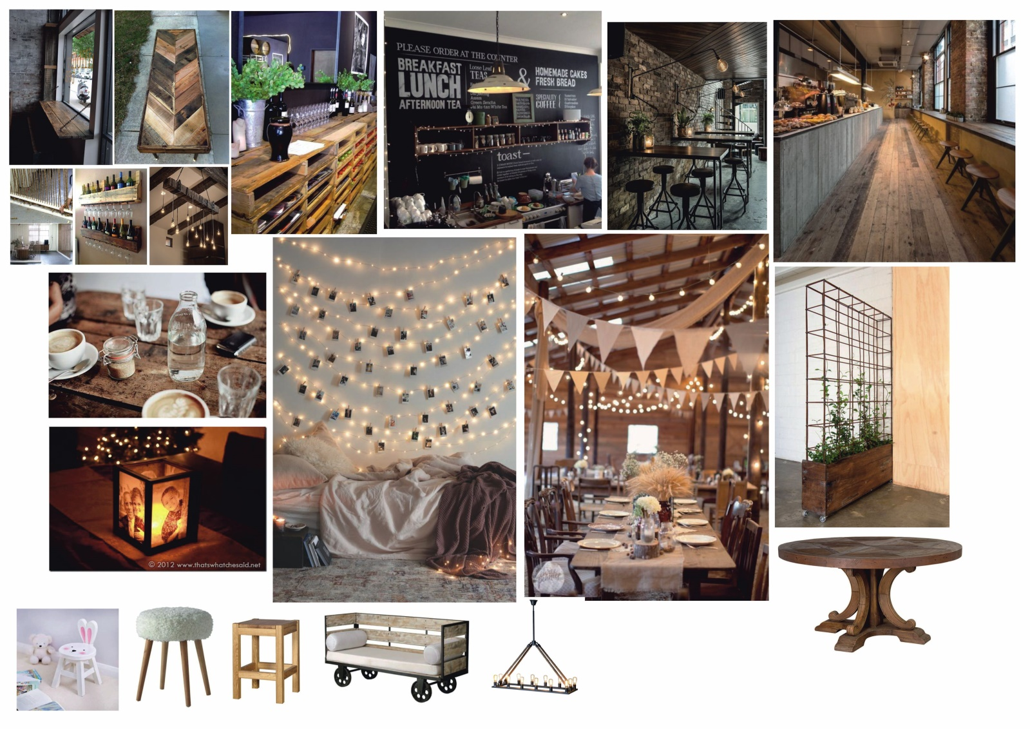

**About the logo:**

We want a logo and icon that visually represents the name “The Crab & Waltzer” and we want it to look classy, not tacky.

And to ideally fit in with the “rustic” look we’re hoping to achieve within.

The logo will be used on the signage outside the café, but also on printed materials (menu, business cards, posters, etc) as well as online (Facebook, social media sites, website, etc). Colour scheme – not entirely sure, but the exterior signage of the cafe will have a black/dark grey background.

In terms of target market, we just want to attract anyone and everyone into the café. It will be mainly a day time focussed operation, but we plan to open a few evenings a week down the line.

Anything else you may need, or questions you may have, you can reach me on [simon.campbell@msn.com](mailto:simon.campbell@msn.com)

Thanks,

Simon